Gosnell High School Mathematics
AMI Day 2: Order of Operations

Name___________________________________ Date________________ Period____
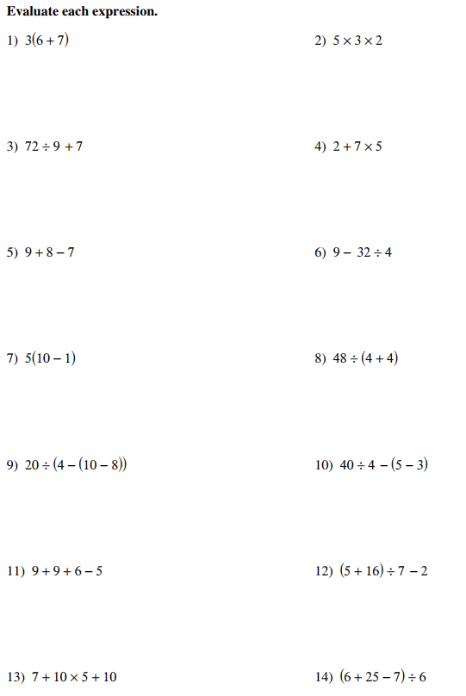
15) $\left(6-4\right)x49÷7$ 16) $(7 x 5)÷5$

