AMI 3-SURVEY OF BUSINESS

Use the following ASCII Binary Number Table to complete the activities below. For this assignment, you WILL NOT use the Decimal Numbers.
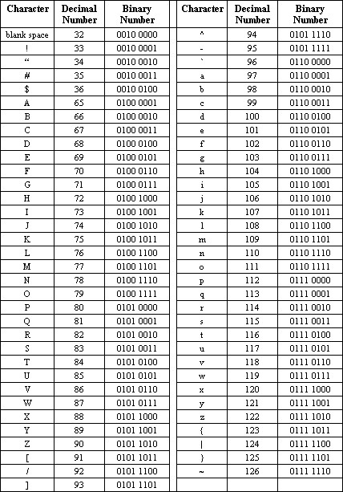

Activities
- Use the ASCII code to write your first name or nickname in binary numbers. Make sure to capitalize as necessary and add a space between your first and last names. Put the letters of your name in the first column.

Letter | 8-Digit Binary Code
- Decode the following. Write your answer on the lines below the code.

01000101 01101110 01101010 01101111 01111001 00100000 01111001 01101111 01110101 01110010 00100000 01100010 01110010 01100101 01100001 01101011 00100001

