AMI 1-FRENCH II

Use the following clues to fill in the crossword puzzle on the next page. Do not include the space between words in the puzzle, but remember that apostrophes (‘) and hyphens (-) will take up a space in the puzzle.

Across
6. Good Evening
9. He’s a friend.
10. What is your name?
12. Good bye
15. Hello
16. His name is…
17. Not bad.
18. And you?
Down
1. What is her name?
2. See you later.
3. My name is…
4. How’s it going?
5. Mister
7. See you soon.
8. I’d like to introduce you to…
10. She’s a friend.
11. Hi
13. Delighted
14. See you tomorrow.
15. Fine

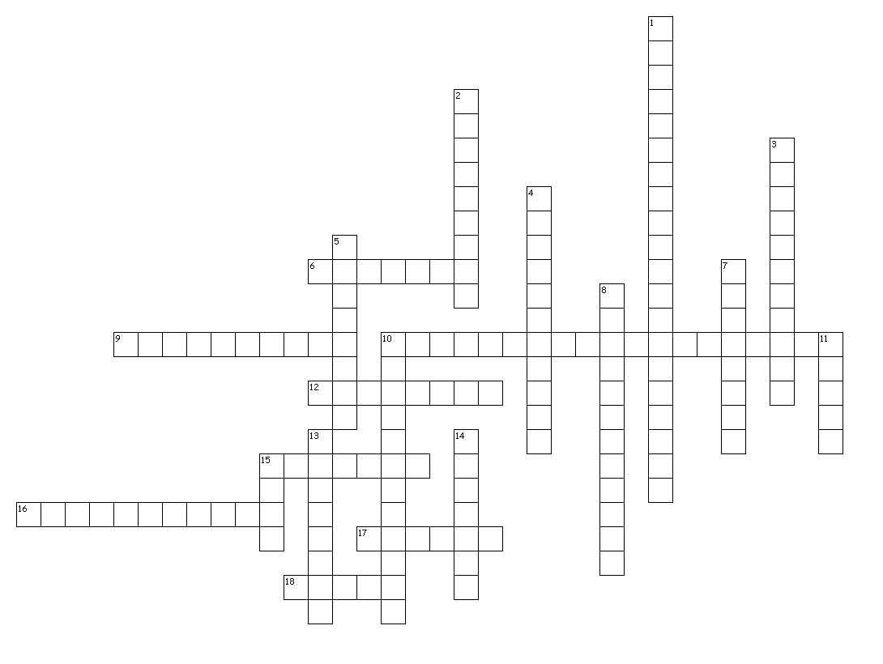
French I Ch 1-1

